**Jupyter Notebook Basics**

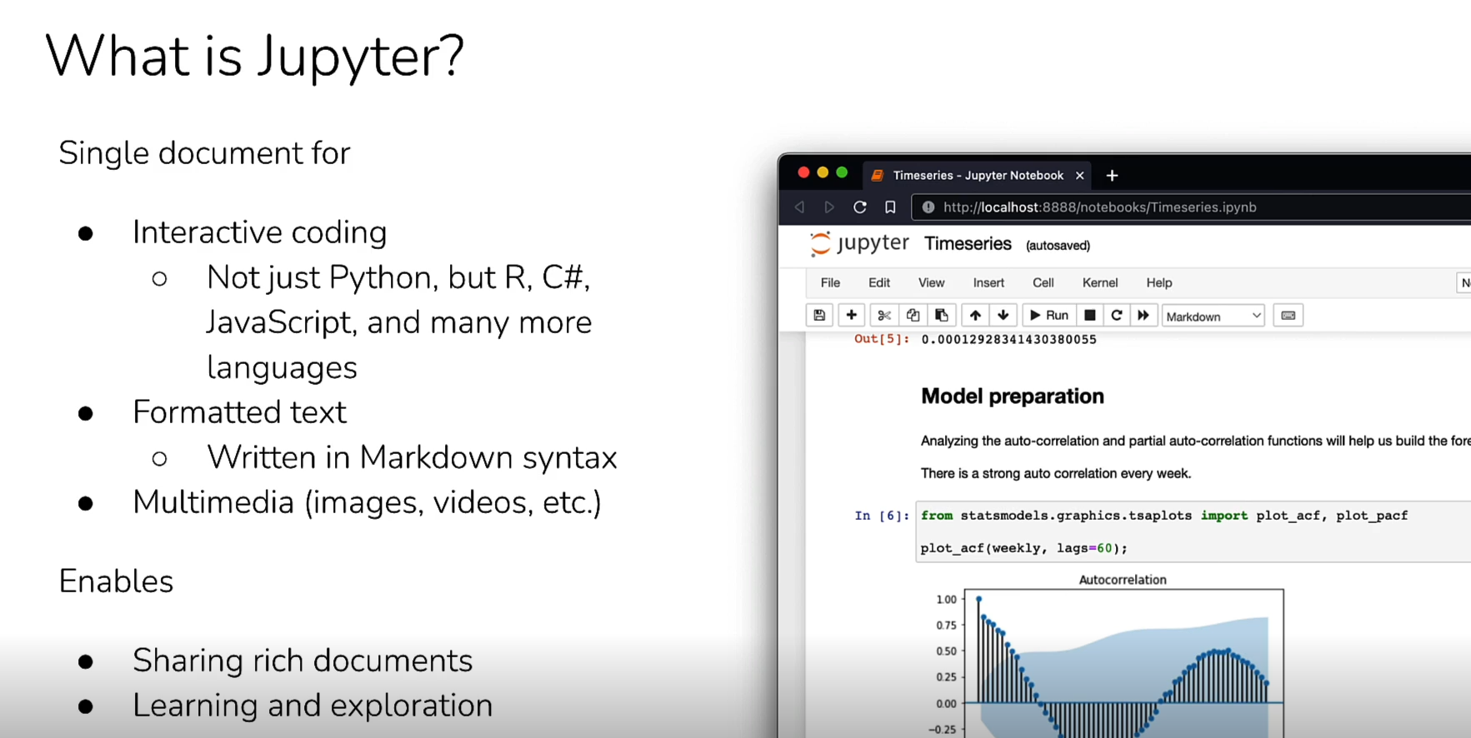

**Jupyter Notebook Setup**

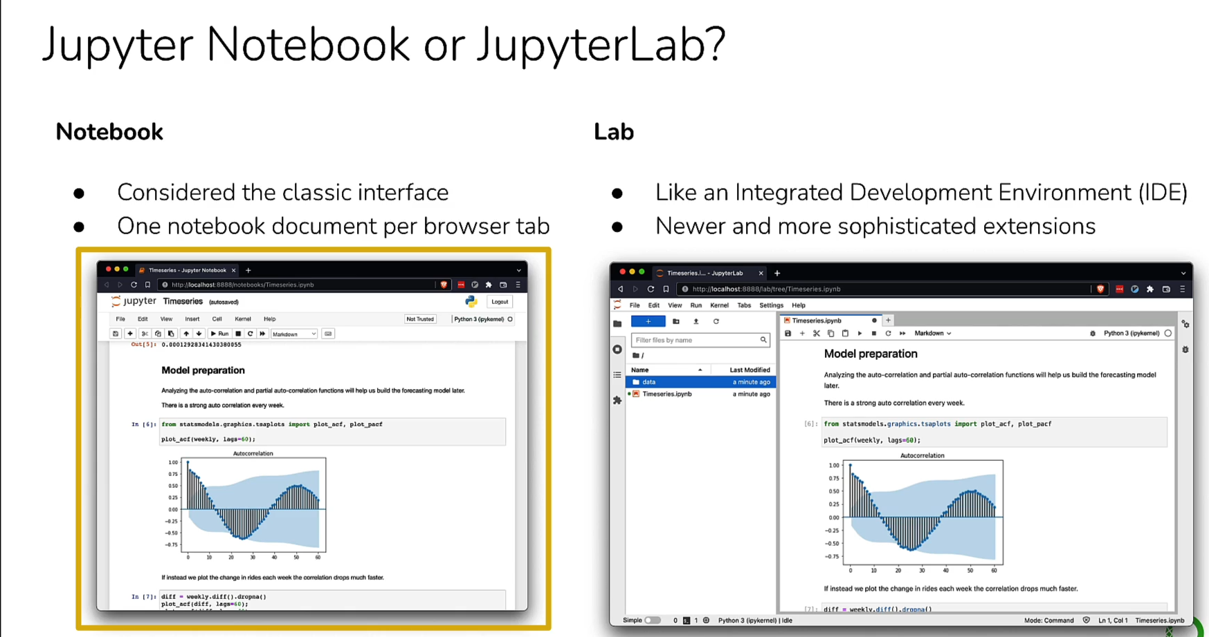

**Get Started with Anaconda and Jupyter**